***Cashmere Winter Scarves For Women***

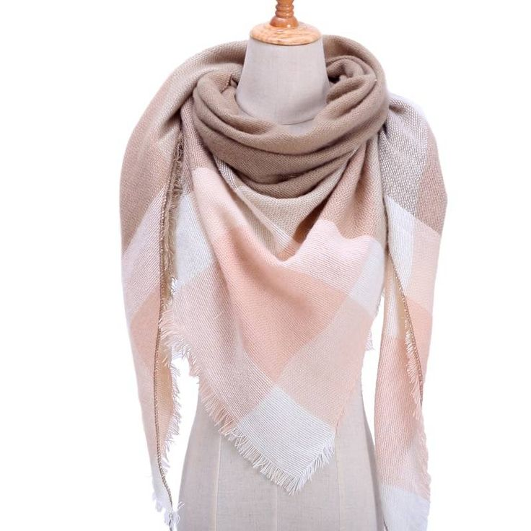

*Texture: Solid color Product: Winter scarf Treatment: Tie-Dye Material: imitation cashmere Popular elements: tassels Style: stretch Use case: Travel, travel Function: keep warm Suitable for the season: winter, spring and autumn*